CENWP-OD-J 3/2/2023

MEMORANDUM FOR THE RECORD

SUBJECT: 23JDA04 MFR South Fish Turbine # 2 forced out of service.

On 28 February the John Day South fish ladder was returned to service for the beginning of the adult fish passage season. Fish turbine pumps 1 & 2 were commissioned and put into service at 1500 and the adult ladder was meeting all FPP requirements. On the morning of 1 March mechanics and operators, during routine inspections, noticed excessive vibration coming from fish turbine pump # 2 (Fig1). It was determined the pump was unsafe to operate and that continuing would cause significant damage. Therefore, the pump was forced out of service at 0930 on 1 March.

John Day maintenance is dropping bulkheads into South fish turbine pump #2 to dewater the unit and investigate the vibration issue. The pumps lower guide bearing was repaired this past July and the vibration may be the cause of another failure. However, that has yet to be determined.

John Day fisheries have adjusted the South fish ladder per the FPP’s one turbine operation. Floating orifices are being pulled and South fish turbine 1 will be run at its maximum output allowable to provide attraction water.

Updates on weir setting, entrance differentials, and channel velocities will be forthcoming.

- Future and Preventative Measures – John Day maintenance is investigating vibration issue by dewatering fish turbine 2. Once the issue is determined a path forward will be planned.

UPDATE: 3/6/2023

John Day maintenance has determined the cause of the vibration to be excessive wear on the lower guide bearing on the pump assembly of South fish turbine pump #2. The bearing was pulled out and journaled to reattach Teflon guide strips (Fig2) for the intermediate propeller shaft. Currently the bearing is being reattached to the pump assembly and the fish turbine pump is expected to return to service by 9 March.

Current ladder operation is following the FPP guidelines for 1 turbine operation. South entrance weir 1 and North Entrance weir 2 are submerged at 8’. Ladder entrances are within the 1’-2’ range and within FPP criteria. Collection channel velocities are averaging 1.7 feet per second in the South fishway. South fish turbine pump #1 output is set at 68 rpms.

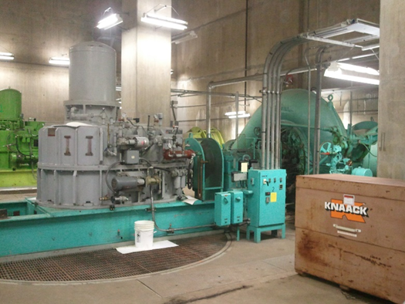
Fig 1: John Day South Fish Turbine Pump #2

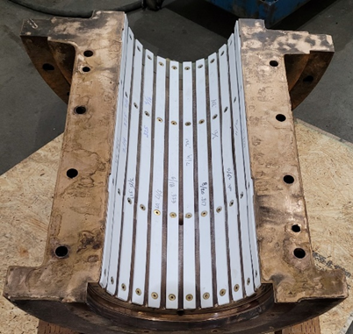
Fig 2: Lower guide bearing disassembled

Sincerely,

JD Project Fisheries

